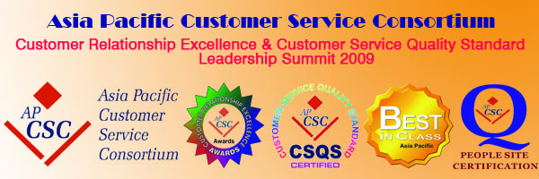

APCSC Customer Relationship Excellence (CRE) and Customer Service Quality Standard (CSQS) Leadership Summit 2009

Presented by Asia Pacific Customer Service Consortium and Hong Kong Customer Service Consortium

Event Date: | 25 – 26 June, 2009
Venue: | Hong Kong
Contact: | Alan Poon or Vanessa Lai
Email: | creawards@apcsc.com
Website: | http://www.apcsc.com/cresummit/index.asp

At this CRE Leadership Summit, distinguished speakers from Hong Kong SAR government departments, academia and market leaders will inspire you with the innovative ideas and CRM wisdom on the following subject matters:
- CRM and Integrated Service Excellence
- Customer Service Quality Standard
- CIS and BPO Service Excellence
- Customer Driven Relationship Management
- Mission Critical Support
- Service Quality and Customer Experience
- Customer Service Knowledge Management

You may also share the success stories of the Customer Relationship Excellence Awards winners with their keynote presentations at the CRE Awards Dinner Ceremony. Witnessing how CRE Awards winners bring new service levels, quality standards and benchmarks to shape the future directions of business practices in making Asia Pacific a better place to live and do business, your company may achieve the goal of market leadership and gain international recognitions!
- How do you retain your valuable customers during recession?
- How do you maintain your competitiveness in the global crisis?
- How do you achieve leadership in different areas to survive with growth?
- How do you create sustainable business success with innovation and CRM?
- How to reduce business costs with self services and environmental strategies?
Don't hesitate to register for the Leadership Summit 2009 to get the answers NOW!

Past Speakers of the CRE & CSQS SUMMIT
Mr. Jason Chu, Chairman of Asia Pacific Customer Service Consortium; Mr. Benjamin Tang, Director of Audit of Audit Commission, Government of HKSAR; Mr. Bryan J Smith, Senior Vice President of American International Assurance Company (Bermuda) Limited; Dr. Damien Marmion, Managing Director of Bupa (Asia) Limited; Mr. William Yeung, Chief Executive Officer of Hong Kong Broadband Network Limited; Dr. Hans Wijayasuriya, Group CEO of Dialog Telekom, PLC; Mr. W. W. Chan, Managing Director of Cascade Limited, Subsidiary of PCCW Limited; Mr. Victor MOK, Executive Vice President, DHL Global Forwarding, Mr. Tom Mehrmann, Chief Executive Officer, Ocean Park Hong Kong, Mr. Anthony Lock, Managing Director of California Red Ltd.; Mr. Alkin Kwong, Vice Chairman & Chief Executive of Hong Yip Service Co., Ltd.; Ms. Cally Chan, Country Manager of Managed Services, Hewlett Packard HK SAR Limited; Ms. Daisy Lam, Operations Director from Octopus Cards Limited; Ms. Jeny Yeung, General Manager of Marketing & Station Business, MTR Corporation Limited; Mr. P.N. Ip, General Manager (T & D) Customer Services Engineer from The Hongkong Electric Co., Ltd.; Mr. Stephen Ho, CEO of CPCNet Hong Kong Ltd., Professor George Huang, The University of Hong Kong, etc.
To register or to find out more about the Customer Relationship Excellence (CRE) and Customer Service Quality Standard (CSQS) Leadership Summit 2009 and the CRE Awards Dinner Ceremony, please click http://www.apcsc.com/cresummit/registration.asp

Immediately register for a 30% early bird discount before 31 March 2009!

